Lesson 2.2 Review Name: ________________________per.___

Identifying Processes; Identify the term as either a density-dependent limiting factor or a density-independent limiting factor. Then explain how each term is a limiting factor on population growth.

- Competition:
Density-dependent
As population increases the resources like food, water and space become limited thereby creating competition.

- Natural disaster (earthquake):
Density-independent
The earthquake will affect all populations present in the area where the earthquake disturbed.

- Parasitism and Disease:
Density-dependent
As the density increases the ease of spreading the disease or the abiltiy for the parasite to trasfer increases

- Human Activities:
Density-dependent (if hunting/ fishing) Predation. Human can limit the pop of whatever the human is after

Density-independent: Habitat loss will affect all populations regardless of density.

- Unusual weather:
Density-independent
It will affect all populations present in the area where the unusual weather occurred.

- Predation:
Density-dependent
The predator will eat and control the prey population

- Herbivory:
Density-dependent
Herbivore population denisty increase which can lead to overgrazing of plants thereby limiting the
food

- Comparing and Contrasting: What is the difference between density-dependent limiting factors and density-independent limiting factors?
Limiting factors that are density dependent arise as a result of the population increasing
Density independent factors affect all populations in an area regardless of population density.

- Applying concepts: If wolves and lynx both prey on the same small animals, will they be under pressure to change in ways that increase or decrease their competition?Explain
They will change in ways to DECREASE the competition. If not and the pressure continues their
population will decrease and possibly not exist in that area. 2 similar species can not occupy the same
niche

- If the wolf or lynx population do NOT change their ways what will most likely happen? What term do we give to this?
This would be an example of the competitive exclusion principle. Whichever predator has the faster
growth rate and success will outcompete the other.

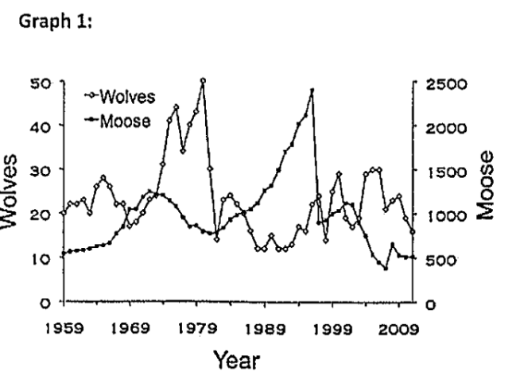
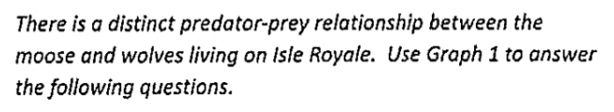

- What limiting factor affects the moose population?
Predation
What limiting factor affects the wolf population?
Competition (and disease, 1980)
- Is the relationship between the wolves and moose
density dependent or density independent?
Explain
Density dependent. The wolves will limit
the deer population as it eats them and as the deer pop is limited the wolves will have only so much to eat and be limited to that deer population.

- On the graph above, properly show the carrying capacity for the moose population & the wolf population.

- Suppose a large carnivore, such as a mountain lion, was introduced to Isle Royale. How would this affect the population of moose and wolf populations? Explain your answer.
The moose and wolf population would both decline. The deer population would be preyed on more and
the wolf population would have less to eat.

- Suppose another herbivore, such as a rabbit, was introduced to Isle Royale, How would this affect the population of moose and wolf populations? Explain your answer.
The wolf population would increase as there is more prey to eat. The moose may be the same (at first)
as there is competition that would lower the population BUT less predation on the moose. As the wolf
population increases the moose population would decrease due to both predation and competition.

